Performance Analysis of Wireless Sensor Networks using Q-learning
Pulugujju Rajesh  Dept. of ECE  B V Raju Institute of Technology  Narsapur, India.  rajesh.p@bvrit.ac.in | Arra Sai Kumar  Dept. of ECE  B V Raju Institute of Technology Narsapur, India.  21211A0413@bvrit.ac.in | Tettu Kandala Manisha Sarayu  Dept. of ECE  B V Raju Institute of Technology  Narsapur, India.  22215A0406@bvrit.ac.in
Addagarla Durga Prasad  Dept. of ECE  B V Raju Institute of Technology Narsapur, India.  21211A0404@bvrit.ac.in | Chalamala Sai Dhanush  Dept. of ECE  B V Raju Institute of Technology Narsapur, India.  21211A0444@bvrit.ac.in
I. ABSTRACT
Wireless Sensor Networks (WSNs) request efficient and versatile routing algorithms to perform well in dynamic situations. Particularly in static node installations, Conventional protocols, such as Ad hoc On-Demand D.V. (AODV) and Destination-Sequenced D.V. (DSDV) sometimes have drawbacks including excessive latency, inefficient use of energy, and increased packet loss. By dynamically choosing the best routes depending on network conditions, reinforcement learning (RL)-based techniques in particular, Q-learning offer a promising way to improve routing. This research compares Q-learning's efficacy to that of Ad hoc On-Demand D.V. and Destination-Sequenced D.V. in terms of critical criteria such as throughput(thrpt), end-to-end delay, and packet delivery ratio in a performance evaluation of WSNs with a fixed number of nodes. Simulation outputs show that Q-learning considerably increases network efficiency by lowering overhead, optimizing path selection, and increasing flexibility to network changes. These findings demonstrate the ability of Q-learning to overcome the limits of standard routing protocols, paving the way for more intelligent and robust WSN designs.
Key words:
Wireless Sensor Networks, AODV, DSDV, Q-learning.
II. INTRODUCTION
Wireless Sensor Networks (WSNs) have become an important technology in many areas, such as industrial automation, healthcare, and environmental monitoring. These networks are made up of widely spaced sensor nodes that gather and send data, frequently in settings with limited resources. In order to maximize network performance, guarantee dependable data transfer, and increase the network's lifespan, efficient routing is essential.

The Routing Protocols
1. Ad hoc On-Demand Distance Vector (AODV)
As a reactive routing protocol, AODV only creates routes, when necessary, which lowers overhead but increases latency while finding routes. It effectively adjusts to changes in the network, but because it asks routes more frequently, it uses more energy.
2. Destination-Sequenced Distance Vector (DSDV)
A proactive routing technology, DSDV updates routing tables on a regular basis. In stable networks, it offers low-latency communication; however, because of its high control overhead, it is less scalable in larger networks.
Network Simulator 2 (NS2)
A well-liked open-source simulation program for network protocol modelling and analysis, including wireless networks, is called NS2. It provides realistic mobility and traffic models and supports a number of routing protocols, including AODV and DSDV. With the creation of trace files for analysis, NS2 makes it possible to evaluate performance based on throughput, delay, packet loss, and packet delivery ratio. This study evaluates advances in routing efficiency, flexibility, and network performance by comparing Q-learning-based routing with AODV and DSDV in a fixed-node WSN using NS2.
Q-Learning
Methods based on Reinforcement Learning (RL), especially Q-learning, present a viable way to improve routing effectiveness in WSNs. Through dynamic path selection depending on current network conditions, Q-learning permits the sensor nodes to adapt and learn. In contrast to conventional protocols, Q-learning continuously improves routing choices, minimizing latency, consuming less energy, and optimizing packet delivery. Enhancing network dependability, lowering control overhead, and increasing responsiveness to shifting network conditions are all made achievable by incorporating Q-learning into WSNs.
III. OBJECTIVES
- To assess how well the Ad hoc On-demand D.V. and Destination-Sequenced D.V. routing protocols work in WSNs using metrics like average throughput, data packets, routing packets, received packets, packet drop, and packet delay.
- To conduct a comparative study in order to determine each protocol's advantages and disadvantages. To improve their performance in dynamic WSN situations, the integration of Q-learning into these protocols will be investigated.
- Identifying the best routing protocol can save energy and increase the lifespan of wireless sensor networks (WSNs).
- To aid in the creation of adaptive and intelligent routing schemes for high-performance and energy-efficient WSN infrastructures.
- To determine the effect of Q-learning on route optimization, control overhead reduction, and network flexibility in WSNs.
IV. LITERATURE SURVEY
[1] A research conducted in 2023 uses NS2 simulations to compare two important routing protocols: Ad Hoc On-Demand D.V. & Destination-Sequenced D.V. To evaluate the effectiveness and dependability of the protocols in WSNs, performance measures including average throughput, packet drop rate, packet latency, and successful data transmission rates are examined.
[2] A research on adaptive protocol parameters for WSNs was carried out in 2023. According to this study, reinforcement learning is utilized to dynamically adjust settings, optimizing every node during runtime, in order to overcome the impracticality of manual tuning. Real-world tests revealed that adaptive protocols outperformed static parameter sets by 16.21%, while simulations indicated performance gains of up to 29.41% in bigger networks.
[3] In 2021, this study utilizes simulation tools such as SUMO, MOVE, and NS2 to assess the performance of Ad Hoc On-Demand D.V. & Destination-Sequenced D.V., and Dynamic Source routing protocols under varied node densities, calculating parameters like as thrpt, PDR and end-to-end latency. Each technique has disadvantages and advantages that make it more suited to one circumstance than another.
[4] In 2020, a study was conducted on the analysis of Ad Hoc On-Demand D.V. & Destination-Sequenced D.V. and Zone routing protocols for wireless sensor networks. Using the Network simulator 2, this research evaluates the performance of the Ad Hoc On-Demand D.V. & Destination-Sequenced D.V. and Zone routing protocols in terms of thrpt, packet loss ratio (PLR), end-to-end latency, and missing packets. Performance is assessed by adjusting node density and speed, demonstrating the effect of diverse circumstances on protocol efficiency and dependability.
[5] In 2019, a study was conducted on the comparative examination of routing algorithms in wireless sensor networks. Using the Network simulator 2, this study evaluates communication and data transmission performance by comparing the Ad Hoc On-Demand D.V. & Destination-Sequenced D.V., and Dynamic Source routing protocols based on parameters such as average thrpt, end to end latency, PDR, node energy, and normalized routing load.
V. METHODOLOGY
a. Software tool used
NS2 (Network Simulator version 2)
- Network Simulator-2 is an open-source computer network simulator for research works.
- The Network Simulator The program was predicts computer network behaviour.
b. Different files used
awk files, nam files, tcl scripts, trace files, xg files.
c. Implementation
The analysis is carried out utilizing the NS2 tool. After creating a static network with 24 nodes, two protocols— Ad Hoc On-Demand D.V. & Destination-Sequenced D.V. are added to the network. The two protocols are subsequently evaluated using various important criterion like thrpt, end-to-end delay, and packet delivery ratio and packet dropping ratio.
The animation of the Ad hoc On-Demand D.V. and Destination-Sequenced D.V. protocols are then acquired using nam files after key metrics have been established using various awk files. The values are displayed in the terminal window using tcl scripts, and graphs are generated using xg files.
Following all of this, Q-Learning, a technique used in reinforcement learning, is added to the process. The method that is used for improving routing accuracy in WSNs is termed as Q-learning. Thus, the performance is examined and tabulated by introducing the concept of Q-Learning.
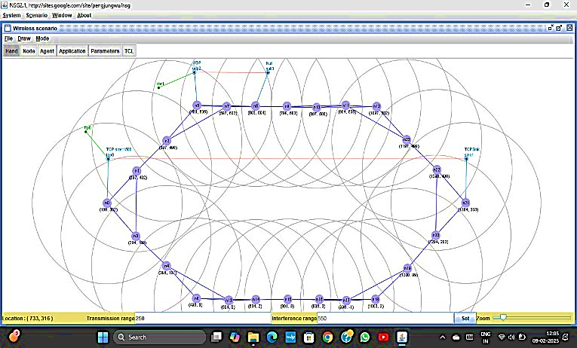
Figure 1: 24-node network
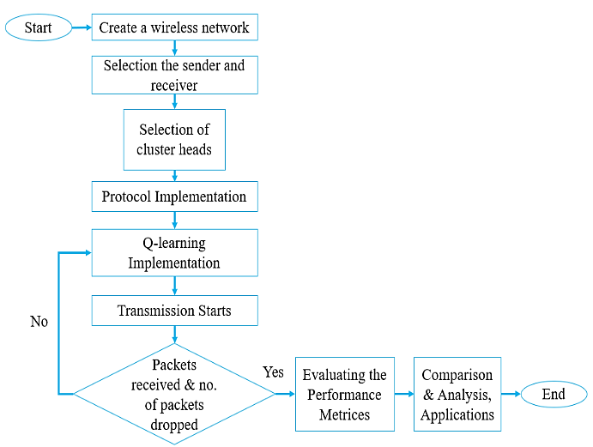
Figure 2: Flowchart
NAM Results:
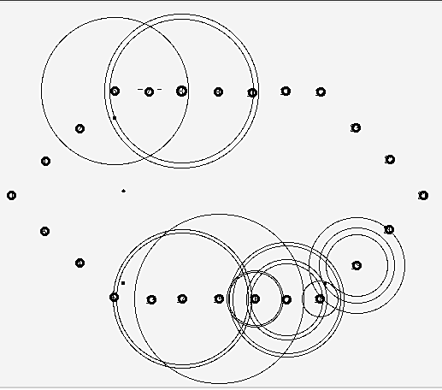
Figure 3: AODV NAM file
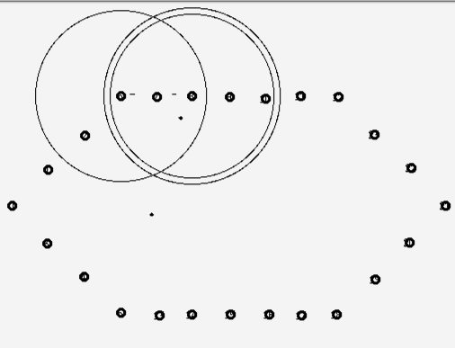
Figure 4: DSDV NAM file
VI. SIMULATION GRAPHS
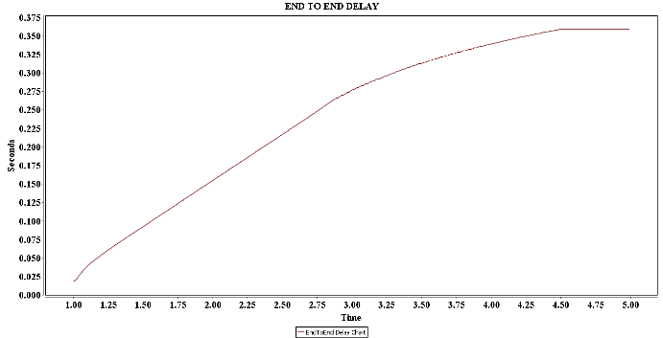
Figure 5: end-to-end delay in AODV
& with Q-learning
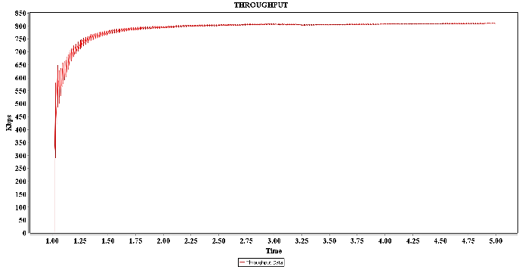
Figure 6: Throughput in AODV
& with Q-learning
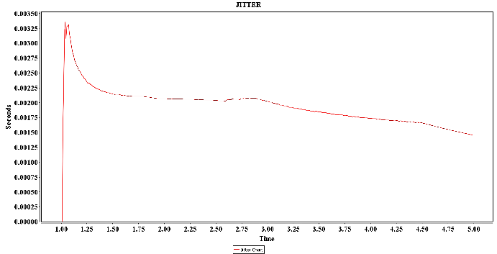
Figure 7: Jitter in AODV
& with Q-learning
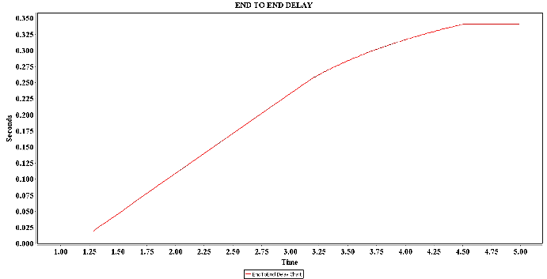
Figure 8: end-to-end delay in DSDV
& with Q-learning
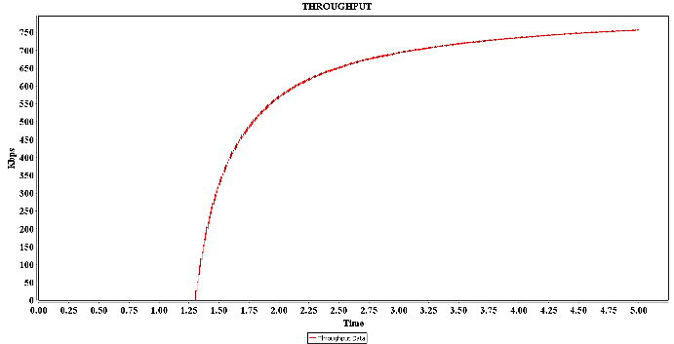
Figure 9: Throughput in DSDV
& with Q-learning
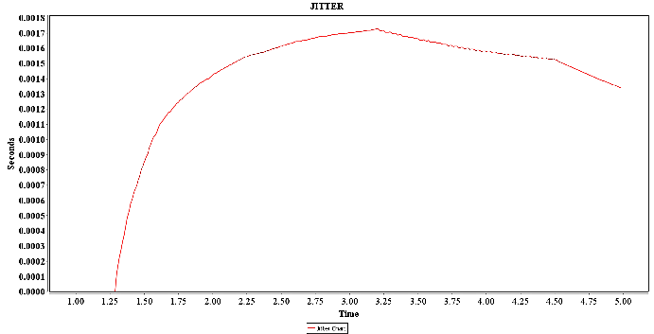
Figure 10: Jitter in DSDV
& with Q-learning
VII. SIMULATION RESULTS
AODV WITH Q-LEARNING:
Q-Table initialized
Node 0 has neighbours: 1 3
Exploiting: Node 0 chooses best action 1 (Q = 0.0)
Reward Computed: Throughput=202.96772904832275, Delay=27.862211516062828,
Loss=8.0188950467942721
Reward=3.1689127951887706
Node 1 has neighbours: 0 2 3
Q-Update:
Q(0 → 1) changed from 0.0 to 1.5844563975943853
Node 1 has neighbours: 0 2 3
Exploiting: Node 1 chooses best action 0 (Q = 0.0)
Reward Computed: Throughput=504.80787805505469, Delay=30.600647130329463
Loss=0.50763194472884376
Reward=25.682109605123397
Node 0 has neighbours: 1 3
Q-Update:
Q(1 → 0) changed from 0.0 to 13.554060181479173
Node 2 has neighbours: 1 5 7
Exploring: Node 2 randomly chooses action 7
Reward Computed: Throughput=217.13904254936568, Delay=45.58881271890775
Loss=1.117536668254778
Reward=10.383346872125962
Node 7 has neighbours: 2 5 8 9
Q-Update:
Q(2 → 7) changed from 0.0 to 5.191673436062981
DSDV WITH Q-LEARNING:
Q-Table initialized
Node 0 has neighbours: 1 3
Exploring: Node 0 randomly chooses action 1
Reward Computed: Throughput=118.02120465693119
Delay=58.238666904270033 Loss=1.727466006636371
Reward=4.6800202072080408
Node 1 has neighbours: 0 2 3
Q-Update:
Q(0 → 1) changed from 0.0 to 2.3400101036040204
Node 1 has neighbours: 0 2 3
Exploiting: Node 1 chooses best action 0 (Q = 0.0)
Reward Computed: Throughput=36.364452464675743
Delay=17.735257380518714
Loss=7.6470794378067737
Reward=-4.2275977877717548
Node 0 has neighbours: 1 3
Q-Update:
Q(1 → 0) changed from 0.0 to -1.0607943472640682
Node 2 has neighbours: 1 5 7
Exploiting: Node 2 chooses best action 1 (Q = 0.0)
Reward Computed: Throughput=831.7248406036407
Delay=79.939602538915167
Loss=4.4899871547194135
Reward=37.466901617711898
Node 1 has neighbours: 0 2 3
Q-Update:
Q(2 → 1) changed from 0.0 to 18.733450808855949
Node 3 has neighbours: 0 1 4
Exploiting: Node 3 chooses best action 0 (Q = 0.0)
Reward Computed: Throughput=953.61679371149137
Delay=43.745190903425772
Loss=2.5423513876937105 Reward=45.808951411218544
Node 0 has neighbours: 1 3
Q-Update:
Q(3 → 0) changed from 0.0 to 23.957480252231083

VIII. COMPARISON TABLE
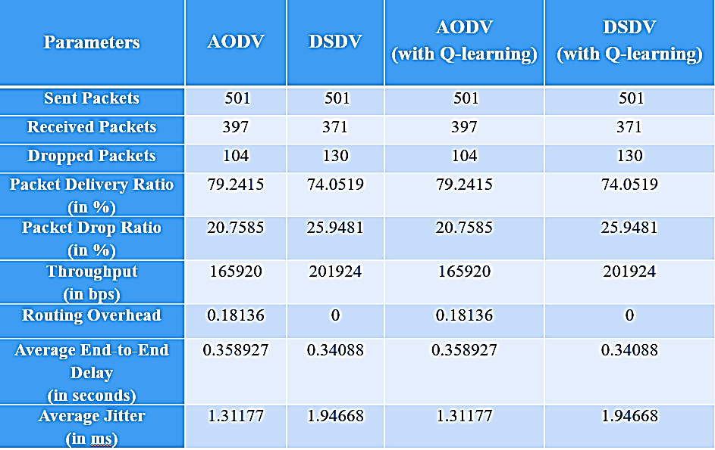
Comparison of AODV & DSDV
IX. CONCLUSION
In this work, we used AODV and DSDV together with Q-learning to assess WSNs performance in the NS2 simulation console. Our findings show that Q-learning generated similar performance measures (PDR, throughput, packet-drop ratio, routing overhead, jitter & end-to-end delay) to traditional Ad Hoc On-Demand D.V. & Destination-Sequenced D.V. protocols for a fixed-node network. This implies that the impact of Q-learning-based optimization is limited in static networks as optimum paths are already provided by traditional routing Techniques. However, we found that Q-learning actively explores, exploits and then takes use of several paths, which may be advantageous in more dynamic environments. Furthermore, Q-learning mitigates energy inefficiencies in DSDV and eliminates needless routing overhead in AODV.
This study can be expanded in the future by applying Q-learning to mobile networks and discovering its benefits in adaptive routing. Furthermore, network lifespan may be improved by fine-tuning the reward function to take energy efficiency into consideration. To improve routing choices, more sophisticated machine learning methods such as Deep Q-Networks (DQN) or Multi-Agent Reinforcement Learning (MARL) can be explored.
X. REFERENCES
[1] T. Vasudeva Reddy, R. Anirudh Reddy, P. Rajesh, Arun Kumar Madupu, S. Harshika, E. Sathwik. “Evaluating AODV and DSDV Routing Protocols for Enhanced Performance in Wireless Sensor Networks” 3rd International Conference on Innovative Mechanisms for Industry Applications (ICIMIA), 2023
[2] P. N. Karunanayake, A. Konsgen, T. Weerawardane and A. Förster, "Q learning based adaptive protocol parameters for WSNs," in Journal of Communications and Networks, vol. 25, no. 1, pp. 76-87, Feb. 2023.
[3] Mahdi, Hussain Falih, Mohammed Salah Abood, and Mustafa Maad Hamdi. "Performance evaluation for vehicular ad-hoc networks-based routing protocols." Bulletin of Electrical Engineering and Informatics 10.2 (2021).
[4] Tabbana, Faiza. "Performance Analysis of AODV, DSDV and ZRP Routing Protocols for Wireless Sensor Networks using NS2 Tool." International Conference on Information Technology Convergence and Services. 2020.
[5] Bujurke, Shreekant, and Layak Ali. "Comparative analysis of routing algorithms in Wireless Sensor Networks." 3rd International Conference on Trends in Electronics and Informatics (ICOEI). IEEE, 2019.
[6] Gautam, Genita & Sen, Biswaraj. “Design and Simulation of Wireless Sensor Network in NS2”. International Journal of Computer Applications, 2018.
[7] Kashyap, Vikash Kumar, et al. "Comparative study of AODV and DSR routing protocols in wireless sensor network using NS-2 simulator." 2017 international conference on computing, communication and automation (ICCCA). IEEE, 2017.
[8] Ghawy, Mohammed & Sanabani, M. “Application and Performance Analysis of DSDV Routing Protocol in Ad-Hoc Wireless Sensor Network with Help of NS2 Knowledge”. Global Journal of Computer Science and Technology, 2017.
[9] Kumar, Vimlesh, Anurag Singh Baghel, and Priyank Mishra. "Performance evaluation of DSDV, AODV and LSGR protocol in ad-hoc networks." 2016 International Conference on Electrical, Electronics, and Optimization Techniques (ICEEOT). IEEE, 2016.
[10] Sharma, Varun Kumar & Shukla, Shiv & Singh, Varun. “A tailored Q- Learning for routing in wireless sensor networks”. Proceedings of 2nd IEEE International Conference on Parallel, Distributed and Grid Computing, PDGC 2012.
[11] Zhang, Yanjun & Wang, Siye & Liu, Zhenyu & Zhou, Wenbiao & Liu, Dake. “Performance analysis of wireless sensor network based on NS2”. 2012

